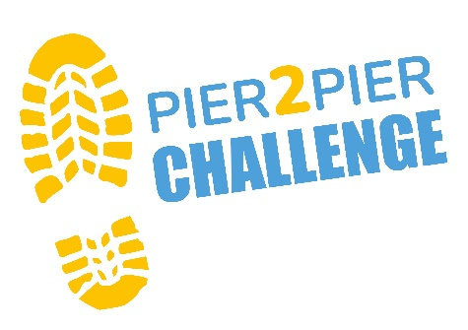

**Mini Pier 2 Pier Frequently Asked Questions**

**What is Mini Pier 2 Pier?**

Mini Pier 2 Pier is a 3.5 mile (approx.) walk around Southwold, starting and finishing at Southwold Pier.

**Who can take part?**

There are no age restrictions for Mini Pier 2 Pier! All children under the age of 18 must be accompanied by an adult. All terrain pushchairs can access the route.

**Will there be toilets on route?**

Toilets are provided at the start and finish, plus there is a public toilet on route.

**What should I wear?**

We suggest the following:

* Walking boots or a comfy pair of trainers – these need to be comfortable and **not new** on the day!
* A good pair of socks.
* Lightweight jacket – windproof/waterproof.
* Rucksack for essentials (water, wet weather and hot weather gear).
* Reusable water bottle.
* Sun cream and hat

**Is there parking at the event?**

You can park in the Southwold Pier car park, parking fees apply.

**Do I have to raise sponsorship money?**

We ask that you try and raise a minimum of £20 in sponsorship. Your entry fee helps covers the running costs of the event. EACH depends on your fundraising to help care for children and young people with life threatening conditions and support their families. We can support you to hit the fundraising target and provide a personal fundraising page, sponsor form and sweepstakes game.

**Can I bring my dog?**

Dogs are allow on the walk but must be kept on a lead. We ask that you leave your dog at home if the temperature on the day is over 20 degrees Celsius.

Still have a question? Feel free to send us an email with any other questions you may have: [events@each.org.uk](mailto:events@each.org.uk)