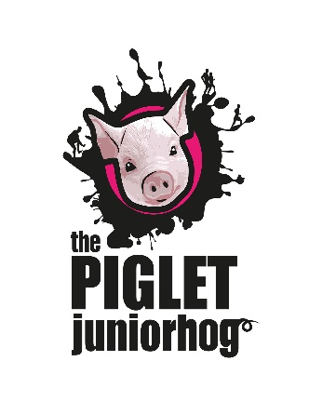
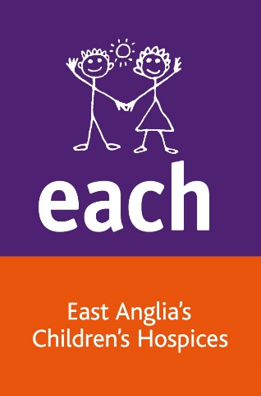

Frequently Asked Questions

What is Piglet – The Junior Hog?
The Piglet, Junior Hog is the entry level version of The Whole Hog and the more challenging Boss Hog. It is open for children (from 8 years +) and for adults who want to try an obstacle and mud course, we guarantee obstacles, water and lots of mud!

Who can take part?
The minimum age is 8 years old, however all children under the age of 12 must run with a participating adult with a maximum ration of 3:1.
Where is it held?
It’s at Wantisden Hall in Suffolk, which is easily accessible via the A14 and A12, the address is: Wantisden Hall, Wantisden Valley, Woodbridge, Suffolk, IP12 3PQ.

What should I wear?
The majority of the course will be off road and we therefore recommend footwear and clothing you do not mind getting dirty! You will be best off in trainers (PLEASE DON’T WEAR SPIKES DUE TO SOME OF THE OBSTACLES) and make sure they are laced up really well. We suggest long sleeved tops and leggings to cover those knees. Gloves would also be a good idea. You will get muddy!

What do I receive when I register?
A month prior to the event, each participant will receive a welcome pack which includes important event information and your participant number wristband. Please ensure you complete the information on the wristband and wear this on the day. All participants must be accounted for throughout the route. These numbers are unique to you and therefore must NOT be swapped with other participants for health and safety reasons. Optional breathable t-shirts (included in the ticket cost) will be available to collect on the day. At the end of the event you will receive a medal.
Do I have to raise sponsorship money?
We ask that you try and raise sponsorship for EACH. We suggest everyone tries to raise a target sponsorship of £20. Sponsor forms are included in your entry pack and must be returned as soon as possible after the event, along with all the fantastic funds you have raised. Tick the Gift Aid box where applicable, so we can make your donations go 25% further for our children, young people and their families.
An online fundraising page will also be created for you when you register for the event with our provider Enthuse. You will receive a link to your personal page via email.

Can I bring my dog?
You can bring your dog to the event but unfortunately dogs cannot take part in this event so they will need to be left with a friend or family member who is not taking part. They will need to be kept on a lead due to livestock on the Estate.

What facilities will be available at the event?
There will be toilets on site. Showers will NOT be available so come prepared, we recommend that you bring an old towel, spare clothes or bin bags to put your muddy clothes in.
There will be a key drop available on the day (to be placed in a named sandwich bag). Please do not leave anything valuable on show in your car. EACH cannot be held responsible for any loss or damage to personal belongings or vehicles.

Water will be available at the end of the event and there will also be a water station on the course. There will be refreshments available to buy at the event village.

Is there parking available?
Yes, parking is in the main area of Wantisden Hall. Please head to Wantisden Hall and you will then pick up signs for the Piglet, Junior Hog event once in the grounds. There is then a short walk down to the event village.

Will there be photos of the day?
EACH will have photographers on site on the day. We would love to see your photos from the day - share them with us on our Facebook event page. If you bring your own camera or smartphone be sure you cover them well to protect them from the water and mud.

Where can I see my friend/family run?

Friends and family can be at the start/finish of the event. We will confirm on the day of any additional viewing points.

What if it rains on the day?
That won’t stop us! Be prepared to get wet!

