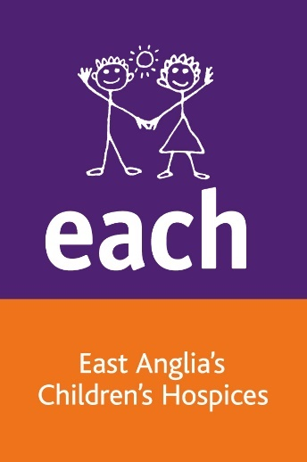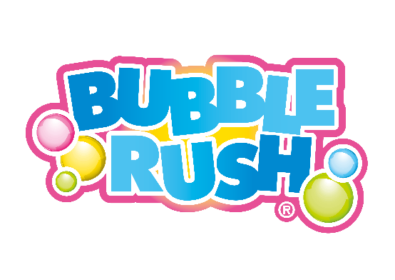

**Norwich Bubble Rush Frequently Asked Questions**

**What is a Bubble Rush?**

Bubble Rush is a fun run that you can walk, jog or run! It is not about speed or winning, it’s about having fun and enjoying the bubbles!

Participants run or walk the course which has four Bubble Stations each with a different coloured foam. The route is two laps of 2.5km so you get double the bubbles! If 5km is too far simply take part in one lap, it is completely up to you!

**Who can take part?**

The Bubble Rush is suitable for all ages! Anyone can take part including pushchairs and wheelchairs. The course is on grass so please bear this in mind when registering as there are areas of uneven ground. Be mindful that if you take the pushchair through the bubbles they may mark or stain the pushchair fabric. Children aged 16 years and under must take part alongside a paying adult and be accompanied throughout the event.

**What should I wear?**

You will receive a Bubble Rush t-shirt on the day of the event which is included in your ticket price. Please wear comfortable clothes and shoes that you do not mind getting messy! The bubbles will turn your white t-shirt different colours.

**Do I have to raise sponsorship money?**We suggest everyone tries to raise £20 in sponsorship. Your ticket prices help us cover the costs to put the event on. Sponsor forms are included in your entry pack and an online fundraising page will also be created for you when you register for the event. You will receive a link to your personal page via email.

**What are the bubbles made of?**

The foam mixture is a soap solution mixed with a food dye to create the different colours. It is water soluble as well as environmentally friendly. It is advised that younger children wear swimming goggles or sunglasses, as they may be head deep at the bubble stations.

**What facilities will be there?**

There will be toilets on site. Showers will not be available so come prepared, we recommend that you bring an old towel, spare clothes and a bin bag to put your bubbly running clothes in. Water will be available at the finish line.There will also be food and refreshments on sale, as well as other stalls and entertainment.

There is not a bag drop so please leave all changes of clothes, picnics and larger items in your car. Personal belongings such as phones and wallets should be kept on you at all times.

**Is there parking available**?

There is parking available at the Norfolk Showground for a suggested donation of £5 per car. Parking will be at the Dereham Gate entrance off Dunham Road, NR9 5EQ. The what3words for the entrance is ///dumps.force.bead.

**Will there be photos of the day?**

EACH will have photographers on site at the event. We would love to see your photos from the day - share them with us on our Norwich Bubble Rush Facebook page. If you bring your own camera or smartphone be sure you cover them well to protect them from the foam. Phone covers are available from the merchandise stall.

**Can spectators watch?**

Friends and family can come along to the event and watch by the bubble arches.

**Can I bring my dog?**

You can bring your dog to the event but unfortunately dogs cannot take part in this event so they will need to be left with a friend or family member who is not taking part. Any dogs at the event must be kept on a lead at all times.

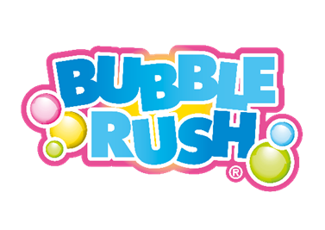

**What if it rains on the day?**

That won’t stop us! Be prepared!