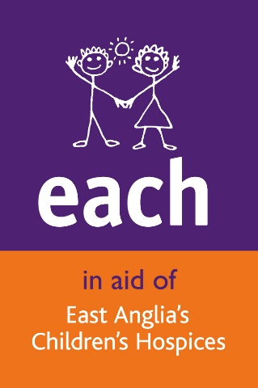

Dear Parent/Guardian,

Fundraising for EACH – INSERT DATE

We are writing from East Anglia’s Children’s Hospices (EACH) to say that INSERT NAME OF SCHOOL would like to fundraise for EACH by ENTER DETAILS OF FUNDRAISER

The money raised will go towards the care EACH provides to local life-threatened children and their families. We provide care and support wherever the family wishes – in families’ own homes, in hospital or at one of our hospices in Ipswich, Milton and of course Quidenham in Norfolk. We are a registered charity and this year need to raise £6 million in donations to deliver our services. This amounts to £16,000 a day, every day of the year.

We are absolutely delighted that SCHOOL have again decided to support us. If you have any queries regards the event then please feel free to contact NAME OF CONTACT AT YOUR SCHOOL.

Kind regards

Your local fundraising team

Cambridgeshire & West Essex  01223 204916  cambs@each.org.uk | Norfolk  01508 500894  norfolk@each.org.uk | Suffolk & East Essex  01473 917965  treehouse@each.org.uk

Registered Charity No. 1069284

